**Food Consumption Patterns & CO2 Emissions**

**Group 3 Members:**

Chen Yiman, Lim Ming Jie Anne, Sherinah Rashid, Shi Chee Liang, Tan Hui Wen, Tan Zexeong

# Introduction

* 1. Greenhouse gas (GHG) emissions such as carbon dioxide (CO2), methane, and nitrous oxide are the main cause of global warming (Caro et al.,2017). Currently, food contributes 19 to 29% of GHG emissions (Temasek et al., 2019). With a projected increase in global population to 9.6 billion in 2050, the demand for animal products will double, thereby increasing GHG emissions from crop and livestock production by approximately 32% (Caro et al.,2017; Tilman & Clark, 2014).

* 1. A local study (Temasek et al., 2019) highlighted that (i) red meats represented only about 11% of consumption per capita by weight but contributed approximately 40% of GHG emissions[1], and (ii) pork accounted for 28% GHG though it was only 6% of consumption per capita. Also, more than 90% of Singapore's food is imported. To reduce our reliance on food imports, Singapore’s ’30 by 30’ target aims to produce 30%[2] of our nutritional needs locally and sustainably by 2030 (Our Food Future, n.d).
  2. Undoubtedly, a person’s food consumption pattern contributes to a significant proportion of a person’s overall GHG impact. Scenario modelling conducted by Clune et al., (2017) highlighted that by substituting meats with alternative meats, there could be up to 30% reduction in the Global Warming Potential (GWP)[3] of food. Locally, the Health Promotion Board (HPB) recommends an optimal diet of 50% fruit and vegetables, and 25% wholegrains and protein (My Healthy Plate, n.d.).
  3. We are keen to conduct exploratory modelling to investigate if changing our food consumption patterns will have an environmental impact. Below is our problem statement:

Changing our food consumption patterns will have an impact

on greenhouse gas emissions.

* 1. The influence diagram and black box model are as below:

# Data Sources

* 1. The data utilised in this study was from 2018, derived from the following sources:
* Singapore Food Statistics 2021 (Singapore Food Agency, n.d.)
* Environmental Impact of Key Food Items in Singapore (Temasek et al., 2019)

* 1. The raw data comprised information as below from 2018, with all GHG emissions were provided in units of kg CO2-equivalent (“GHG_Breakdown_By_Source” sheet):

|  |  |  |  |
| --- | --- | --- | --- |
| Key food items | Type of food – chilled, fresh, frozen | Country source | Percentage of total per key food item |
| Production GHG/kg | Processing GHG/kg | Transportation GHG/kg |  |

The Production, Processing and Transportation values were summed to derive the values for a new field “Total GHG per kg per source”. This field was then multiplied with the “Percentage of total per key food item” to derive another new field, “Contributing GHG per kg per source” (“Input_Model” sheet, section titled ‘Raw Data/Working’).

* 1. The total food consumption data was provided at 365kg per capita. We assumed that the total annual food consumption per capita will not change i.e., remains at 365kg for 2030.
  2. Consequently, the data model was created (“Input_Model” sheet, section titled ‘Data Model).
* The individual percentages of each food item from each source were divided against the total of 365kg to derive the ratio of each key food items in the 2nd column
* For each food item, the contributions of production/processing/transportation GHG were summed to arrive at column 4 of average GHG/kg for each food type
* The total GHG emissions derived in the last column are the sums of the individual GHG contributions per their total weight consumption

|  |  |  |  |  |
| --- | --- | --- | --- | --- |
| **Key Food Items** | **Ratio of Respective Key Food Item (%)** | **Amount of Key Food Item Consumed (kg)** | **Average GHG Emission per kg of Key Food Item (kg CO 2 eq per kg of food)** | **Total GHG Emission per Key Food Item (kg CO 2 eq)** |
| Beef | 0.82% | 3.0 | 24.29 | 72.87 |
| Mutton | 0.55% | 2.0 | 16.41 | 32.81 |
| Pork | 6.03% | 22.0 | 11.95 | 262.80 |
| Chicken | 9.32% | 34.0 | 3.52 | 119.84 |
| Duck | 0.55% | 2.0 | 4.21 | 8.42 |
| Eggs | 6.03% | 22.0 | 3.08 | 67.75 |
| Fish | 4.11% | 15.0 | 5.52 | 82.84 |
| Other Seafood | 1.64% | 6.0 | 5.26 | 31.57 |
| Fruits | 19.73% | 72.0 | 0.40 | 29.15 |
| Leafy vegetables | 4.38% | 16.0 | 0.42 | 6.80 |
| Other Vegetables | 21.92% | 80.0 | 0.82 | 65.53 |
| Rice | 12.33% | 45.0 | 2.57 | 115.79 |
| Wheat | 12.60% | 46.0 | 0.72 | 33.24 |

# Computation and Analyses Performed

* 1. The objective of the analyses is to explore the change in annual GHG emissions per capita, by changing the ratios of food consumption and including relevant constraints. The decision variables are (a) food consumption ratios (%meat, %veg & fruits, %grains), and (b) ratio of foods imported or produced locally.
  2. The following assumptions and considerations will be considered for the analyses:
* The following factors will not be considered for imports:
  + As the supply and demand, financial regulation and transportation are different for different countries, food pricing will have no impact on the analysis.
  + Countries are assumed to have sufficient resources and are willing to sell.
  + It will be assumed that each import country’s offerings of food types or produce for export to Singapore will not change.
* The total annual food consumption per capita will not change, and the value will remain constant up to 2030.
* Annual GHG emissions per-capita will remain constant up to 2030.
* Singapore will achieve the 30 by 30 goal, and Singapore residents will support and consume local produce regardless of pricing or preference.
* To circumvent possible calculation issues where there is incomplete data, only data on food types from countries that make up around 80% of total foods will be used. It is worth to note that the percentages used each import item in the model are ratios derived from their original values since only 80% of most of the import percentages were available from research. Below is an example for the ratios derived for chicken.

* 1. The output variable for the model is as below (“Input_Model” sheet, section titled ‘Output’):

**Annual GHG Emission per capita (kg CO2 eq)**

The total GHG emissions is the sum total of all GHG emissions of the calculated values for each food type in the last column of table 1.

* 1. The input values for the model were as below (“Input_Model” sheet, section titled ‘Input’):

**Total food consumption per capita**

This would be the total food consumption of 365kg per capita as stated in Paragraph 2.3.

**Decision Variables**

There were two decision variables that were used to enact changes in the modelling, and 1 for trade-off analyses.

1. Food Consumption Ratios

The current food consumption ratios as of 2018 in Singapore of 29.04% meat, 24.93% grains, and 46.03% fruits and vegetables were calculated from their individual weight in kgs over the total of 365kg per capita food consumption. The HPB ideal food consumption ratios of 25%, 25% and 50% respectively were also included as constraints for the model.

1. Food Supply Mix

The ratio of locally produced food to import as of 2018 was calculated at 3% and 97%. The ideal targets in line with Singapore’s 30 by 30 target was also included at 30% and 70% as constraints for the model, based on the above assumptions.

1. Diet Alternatives (For trade-off analyses)

This was included for the trade-off analyses and comprised three alternatives – plant-based meats, cultivated meat, and insects. The parameters included were the average % reduction in GHG emissions as compared to meats based on literature review, as well as a column to toggle the respective percentage of each alternative.

**Data Table to Set Minimum Values**

Initial modelling efforts highlighted that Solver would change the food consumption ratios to only comprise fruits and vegetables and completely remove meat from diets. To circumvent this, a minimum value of 20% was included to ensure that the ratio of food items from 2018 would **REDUCE** no more than 20% in 2030 with allowance for increase of consumption of another food item. This value was chosen as an arbitrary value as it seems that this would be a comfortable figure by which an individual may be willing to change their diet. This figure can be toggled further based on any existing data.

Using this 20%, the ratio of food items for 2030 was computed by multiplying 80% to the original ratio of food items in 2018 and set as minimum values. To further ensure that all the food sources will remain as is to ensure food diversity, a minimum value of 1% was set per food item.

**Data Model**

This would be the values as stated in Paragraph 2.4.

* 1. The information utilised for the Solver in Excel was as follows:

|  |  |
| --- | --- |
| **Fields** | **Values** |
| Objective Cell | Annual GHG Emission per capita |
| By Changing Variable Cells | Percentage of Respective Key Food Item or percentage of food from each source |
| Constraints | * Quantity of food consumed per capita remains unchanged at 365kg[4] across all scenarios * Food supply   + Import = 70% in line with 30 by 30 target   + Local = 30% in line with 30 by 30 target * HPB optimal diet   + Meat, eggs, seafood = 25%   + Grains = 25%   + Fruits & vegetables = 50% * All % of food sources must add up to 100% * All food sources contribution can only be reduced by up to a maximum of 20% * All food sources must contribute to at least 1% of each food type |

# Results

* 1. Based on the input values in Section 3.4, the calculated GHG emissions is 929.42 kg CO2-eq.
  2. Using this calculated GHG emissions, we developed a baseline model, in which Singaporeans adjusted their diet in accordance with HPB’s optimal diet stated in Para 1.3 (“Baseline_Model_Optimal_Health” sheet). As seen below, simply changing the diet resulted in a 14% decrease in GHG emissions, from 929.42 to 796.21. This can be attributed to decrease in meat consumption across all meat types, especially of pork and chicken (See Annex 1 for the changes in Ratios of Respective Key Food Item).

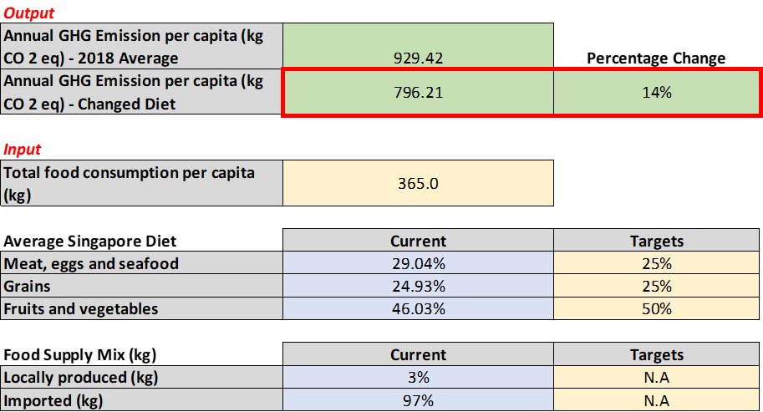

# Trade-off & Scenario Analyses

* 1. Our baseline model allows us to examine how decisions on the Singaporean diet can influence the GHG emissions from our food consumption. In addition, we explored how food production policies, and replacing our diet with various types of meat alternatives may have an impact on GHG emissions. We outlined them into 2 possible scenarios which build on each other.

**Scenario 1: Baseline Model + Meeting Singapore’s 30 by 30 goals**

* 1. The calculated GHG emissions in the baseline model is 835.52 kg CO2-eq. This scenario considers Singapore meeting its target of locally producing 30% of nutritional needs (“Scenario1_Optimal+30by30” sheet). In our input and baseline models, only 2% of Singapore’s food is locally produced. Increasing it to 30% across selected food types[5] showed that GHG emissions could be reduced further by 15% from a changed diet.

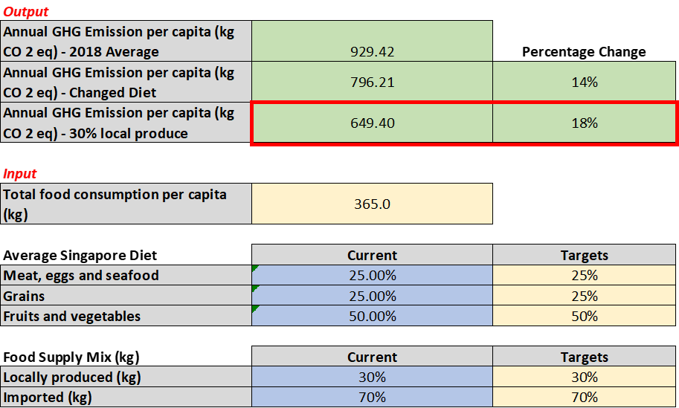

* 1. From the Solver results, many of the majority food sources were changed to meet the 30% local produce targets and still maintain low GHG emissions. Notably, beef, eggs, other veg, fish and other seafoods should be sourced from closer countries, with other vegetables, fish and eggs recommended to be mainly locally produced. It is observed that some percentages increased to greater than 100% in the examples of the pineapple fruit, wheat and eggs being favoured by the model to be the primary food types as the lowest GHG contributors. It should be noted that not all recommendations are feasible and policy makers would need to balance these considerations for price reasonableness and feasibility of local produce.

|  |  |  |
| --- | --- | --- |
|  | **Majority Sources of Each Food Type[6]** | |
| **Food Type** | **BEFORE** | **AFTER** |
| Chicken | 55.4% frozen - Brazil | 78% fresh - Malaysia |
| Pork | 29.6% frozen - Brazil | 74% frozen - Brazil |
| Beef | 39.6% frozen - Brazil | 75% frozen - New Zealand |
| Eggs | 81% Malaysia, 19% Singapore | 108.3% - Singapore |
| Fruits | 21.8% Watermelon - Malaysia | 130.9% Pineapple - Malaysia |
| Other Veg | 97% import, 3% Singapore | 86.2% - Singapore |
| Wheat | 63.8% - Australia | 119.1% - Australia |
| Rice | 43.5% - Thailand | 78% - Vietnam |
| Leafy Veg | 87% Import, 13% Singapore | 79% Import |
| Fish | 95% Import, 5% Singapore | 79% - Singapore |
| Other Seafood | 98% import, 2% Singapore | 79% - Singapore |

**Scenario 2: Scenario 1 + Meat Alternatives**

* 1. The other scenario we explored after adjusting diet and local food production percentage was to explore change in GHG emissions by replacing meats with other meat alternatives (“Scenario2_Scenario1+MeatSub” sheet). There are 3 main types of meat alternatives - (1) plant-based meats, (2) cultivated meats, and (3) insect substitutes.

* 1. Plant-based meats look and taste like real meat but are made entirely from plants and thus there are no GHG emissions from animal feeding and gas release (Lusk et al., 2022). Cultivated meats on the other hand are cell-based meats grown in vats (Tuomisto, & Teixeira de Mattos, 2011). While it also features no GHG emissions due to animal feeding and gas release, its CO2 contributions are mainly from the electricity used to grow the meats. Hence, its emissions can be higher than simply growing animals[7] for meat if the energy source is not green.
  2. Lastly, insects as a meat alternative are extremely efficient in converting resources into nutrients, and also require much less upkeep than animals. Therefore, it has the lowest GHG emissions[8] amongst all the alternatives. However, it is currently not a full substitute for meat and is mainly added as a protein.
  3. Both plant-based and cultivated meats have already received approval for consumption in Singapore, while SFA is currently seeking inputs for insect consumption. However, in consideration of the points raised earlier, only the option of plant-based meats is a realistic alternative in the near future. We can see in the figure below that by simply replacing 25% of our meat consumption with plant-based meats, we can further reduce the GHG emissions by another 15%.

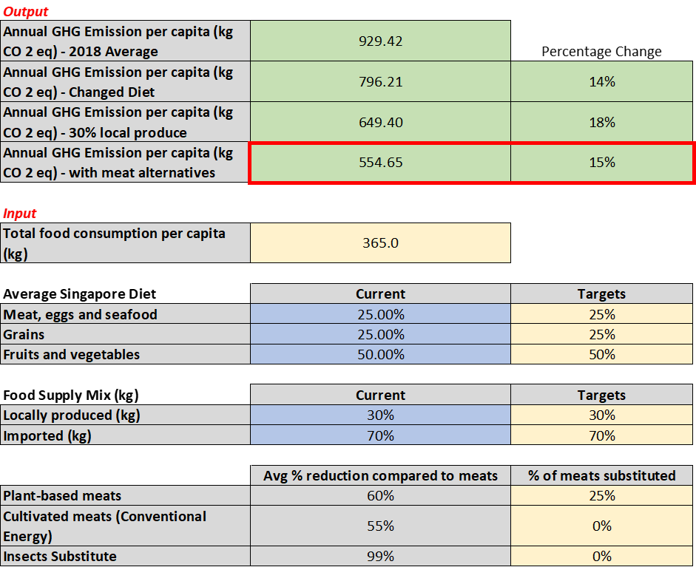

* 1. The GHG emissions for the various models are visually represented in the graph below. We can see that there are various ways to reduce Singapore’s GHG emissions. Comparing the baseline model, and Scenarios 1 and 2, changing parameters such as diet, food production policy, and meat substitutes can lead to an overall reduction of 40% in GHG emissions[9] .

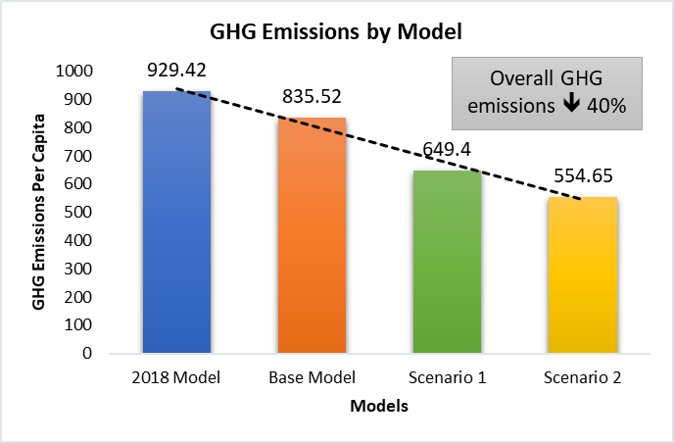

# Sensitivity Analysis

* 1. The sensitivity analysis was based on Scenario 1 and sought to analyse the impact of removing one or more countries as an exporter of one key food item, beef, due to possible uncontrollable factors such as bovine diseases. Beef was chosen as it has the highest GHG emissions of all the meats. Currently, there are 3 countries which import beef to Singapore – Brazil, Australia, and New Zealand – of which the former 2 have the highest GHG emissions per kg. Sensitivity analysis will be performed based on two test cases: (a) Assume Australia is unable to export, and (b) Assume Brazil is unable to export. Consequently, the sources of chilled and frozen beef with shift to New Zealand and the other remaining country.

* 1. The following steps were performed for the analysis (“Sensitivity Analysis” sheet):
* Import ratios were first created to define the distribution of export between New Zealand and the remaining country. For example, under test case (a), if Australia was unable to export, then the ratios of imports to Singapore were calculated for New Zealand and Brazil. If 100% of import was from Brazil, then New Zealand would have 0%, if 80% was from Brazil, then New Zealand would have 20% and so on.
* Based on this ratio, Yiman to fill in **ALL** the steps on how we derived the computation of figures, step by step, and how we calculated the yellow and blue boxes i.e., everything.

Consequently, 2 tables for each test case were created for the analysis, with one calculating the total GHG emissions based on the percentage of food items (see example below), and the other based on absolute GHG emissions.

* 1. The graph for the sensitivity analysis is as below.

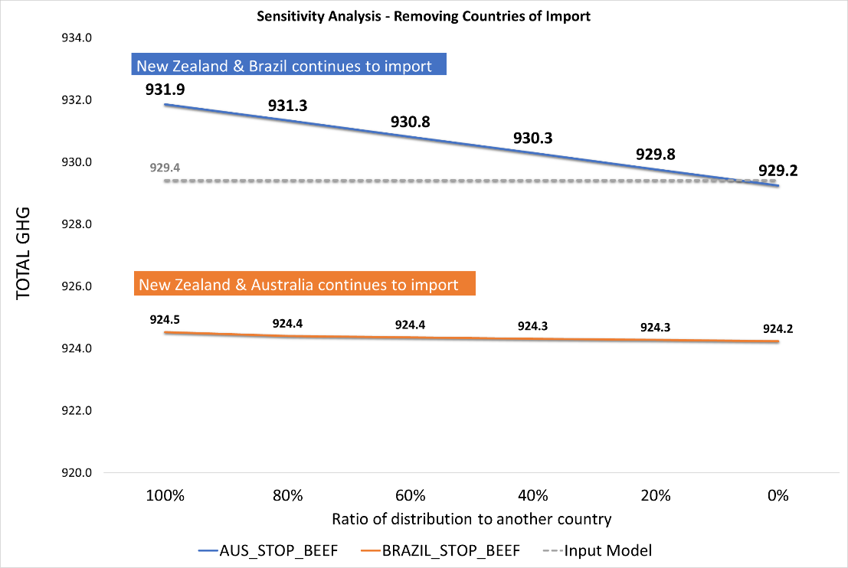

* 1. The overall GHG emissions per capita for test case (b), when Brazil stops its export, is lower than the GHG emissions per our input model (929.42), and test case (a), when Australia stops its export. Comparing the values at import ratio 100:0, the GHG emissions for test case (a) (i.e., Brazil 100%, New Zealand 0%) was 931.9, approximately 7.4kg CO2-eq higher than GHG emissions for test case (b) (i.e., Australia 100%, New Zealand 0%).

* 1. Specifically for test case (a), there is a noticeable decrease in GHG emissions based on the distribution of import ratios. If Brazil were to take 100% of the imports, the GHG emissions would be 931.9. This would decrease by 2.6kg CO2-eq if New Zealand were to take on 100% of the import to Singapore. Conversely for test case (b), simply removing Brazil decreased the overall GHG emissions by approximately 4.89kg CO2-eq as compared to the input model, and there was minimal effect from the import ratios on the overall GHG emissions.
  2. These results show that Brazil’s contribution to GHG emissions is considerable, as removing it reduces the GHG emissions more than when Australia is removed. Thus, in the event of bovine disease in Australia, New Zealand would be the preferred option to completely replace Australia’s import so that the corresponding GHG emissions could be appreciably reduced.

# Conclusion

* 1. It is evident from the exploratory modelling that dietary choices are related to environmental sustainability in terms of greenhouse gas emissions. Our analyses demonstrate that there are diets that would have a significant impact on the annual GHG emission per capita, which will have a global impact if they were to be widely adopted. Of all the models, substituting meat alternatives was shown to be the most significant in decreasing the GHG emission on an individual level, followed by consuming food produced locally, and lastly, by changing our food consumption pattern to the ideal ratios as suggested by HPB.

* 1. While these models show that changes in food consumption patterns will have an impact on GHG emissions, the modelling is not without limitations. Although interpretation of the results suggests that the alternative dietary choices are environmentally beneficial, it does not mean that these would be beneficial for our human health, which our model does not consider. Further, the models do not consider factors such as pricing of food items, which is key in determining Singapore’s selection of countries for import of key food items. Similarly, it uses data on an aggregated level (i.e., frozen, chilled, and fresh meats), and does not consider other types of food, such as canned meats, which also contribute to GHG emissions. Additionally, the modelling highlights only 1 best source of food import for the lowest GHG emission, and not a range of ideal sources. Stakeholders using the models would still need to consider the feasibility and practicality of the proposed solution from the modelling.
  2. The dietary choices that individuals make are influenced by a multitude of factors such as culture, nutritional knowledge, price, and availability, all of which must be considered if we are to advocate for changes in food consumption patterns so as to enact a greater impact on environmental sustainability for Singapore.

# References

Caro, D., Davis, S.J., Bastianoni, S., Caldeira, K. (2017). Greenhouse Gas Emissions Due to Meat Production in the Last Fifty Years. In: Ahmed, M., Stockle, C. (eds) *Quantification of Climate Variability, Adaptation and Mitigation for Agricultural Sustainability*. Springer, Cham. <https://doi.org/10.1007/978-3-319-32059-5_2>

Clune, S., Crossin, E., & Verghese, K. (2017, January). Systematic review of greenhouse gas emissions for different fresh food categories. *Journal of Cleaner Production*, *140*, 766–783. <https://doi.org/10.1016/j.jclepro.2016.04.082>

Lusk, J. L., Blaustein-Rejto, D., Shah, S., & Tonsor, G. T. (2022). Impact of plant-based meat alternatives on cattle inventories and greenhouse gas emissions. *Environmental Research Letters*, *17*(2), 024035. Retrieved on October 6, 2022 from <https://search.library.smu.edu.sg/permalink/65SMU_INST/1ba19kd/cdi_iop_journals_10_1088_1748_9326_ac4fda>

*My Healthy Plate*. (n.d.). Retrieved October 6, 2022, from <https://www.healthhub.sg/programmes/55/my-healthy-plate#:%7E:text=For%20optimal%20health%2C%20eat%20a,foods%20including%20those%20containing%20calcium.&text=Buy%20groceries%2Fmeals%20with%20the,salt%2C%20sugar%20and%20trans%20fats>

*Our Food Future*. (n.d.). Retrieved October 6, 2022, from https://www.ourfoodfuture.gov.sg/

Temasek, Deloitte, & Agency for Science, Technology and Research (A*STAR). (2019, October). *Environmental Impact of Key Food Items in Singapore October 2019*. Retrieved September 25, 2022, from <https://www.ecosperity.sg/content/dam/ecosperity-aem/en/reports/Environmental-Impact-of-Key-Food-Items-in-Singapore_Oct2019.pdf>

Singapore Food Agency. (n.d.). *SFA | Singapore Yearly Food Statistics*. Retrieved September 20, 2022, from <https://www.sfa.gov.sg/docs/default-source/tools-and-resources/yearly-statistics/yearly-food-statistics.xlsx?sfvrsn=470a1446_2>

Tilman, D., & Clark, M. (2014). Global diets link environmental sustainability and human health. *Nature,* *515*, 518–522. <https://doi.org/10.1038/nature13959>

Tuomisto, H. L., & Teixeira de Mattos, M. J. (2011). Environmental impacts of cultured meat production. *Environmental science & technology*, *45*(14), 6117-6123. Retrieved on October 6, 2022 from <https://doi.org/10.1021/es200130u>

*Understanding Global Warming Potentials*. (2022, May 5). US EPA. Retrieved September 27, 2022, from <https://www.epa.gov/ghgemissions/understanding-global-warming-potentials>

Van Huis, A., Van Itterbeeck, J., Klunder, H., Mertens, E., Halloran, A., Muir, G., & Vantomme, P. (2013). *Edible insects:* *future prospects for food and feed security* (No. 171). Food and agriculture organization of the United Nations. Retrieved on October 6, 2022 from <https://doi.org/10.1371/journal.pone.0014445>

1. These figures considered the entire Life Cycle Analysis of the food, starting from the production of farm activities, slaughtering, packaging, storage, to logistics involved in transport and import of food into Singapore, and food waste.
2. At the point of the launch of the target, the target was 10% for both eggs and fish, and 20% leafy vegetables.
3. GWP was developed to allow comparisons of the global warming impacts of different gases. The larger the GWP, the more a given gas warms the Earth compared to CO2 over 100 years (Understanding Global Warming Potentials, 2022).
4. 365kg per capita based on 2018 figures.
5. Selected food types currently announced are eggs, fish, and leafy vegetables.
6. All other sources have reduced to 1%
7. Current research shows that GHG emissions would be higher for all other meat types except for beef if conventional energy like burning of fossil fuel is used.
8. Up to 99% lower GHG emissions than pork in the production phase of the Life Cycle Analysis.
9. Calculated as total percentage difference between the Scenario 2 + Meat Alternatives against the 2018 GHG emission per capita figures.